Slime Lab Name(s):

Purpose:

Learn about the properties of polymers by performing various polymerization reactions to make 2 or 3 different types of slime. The ratio of baking soda to contact lens solution you use affects the texture of your slime.

How to make each slime texture:

|  |  |
| --- | --- |
| **Sticky** | **Thick** |
| ⅓ cup of glue | ⅓ cup of glue |
| 2-3 drops of food coloring | 2-3 drops of food coloring |
| 1 level spoonful of baking soda | 2 level spoonfuls of baking soda |
| 3 level spoonfuls of contact solution | 9 level spoonfuls of contact solution |

Procedure:

1. Pour the glue into the cup
2. Add 2-3 drops of your choice of food coloring and stir until well mixed.
3. Add the baking soda and contact lens solution.
4. Stir with a spoon or with your hands. The slime will be quite sticky at first, but will get less so with more mixing.
5. You should now have 2 different consistencies of slime!

**Discussion Questions:**

1. You have now made 2 or 3 (if you had extra time) different types of slime. Roll each one into a ball and try to bounce it on the floor. How are the slimes different in terms of texture, appearance, and how it bounces? How are they similar?

**Differences:**

|  |  |  |  |
| --- | --- | --- | --- |
| **Type** | **Texture** | **Appearance** | **Does it bounce? (Y/N)** |
| **Sticky** |  |  |  |
| **Thick** |  |  |  |

**Similarities:**

1. Now we will begin taking measurements to create a stress-strain curve. For the Thick slime:
   1. Roll one piece into a cylinder that is 10 cm in length and measure the radius of the end of the cylinder, then calculate the circle’s area.
   2. Roll the other piece into a cylinder that is 15 cm in length and measure the radius of the end of the cylinder, then calculate the circle’s area.
   3. For each cylinder:
      1. Attach the cylinder to the force gauge approximately 1 cm away from the end of the cylinder.
      2. Start pulling slowly on it. Record the length of the cylinder and the associated force at 3 different points in the table.

**10 cm cylinder measurements:**

Circle radius: _______ cm = _______ m

Circle area: πr2 = _______ m2

|  |  |  |  |
| --- | --- | --- | --- |
|  | **Data Point 1** | **Data Point 2** | **Data Point 3** |
| **Length (cm)** |  |  |  |
| **Force (N)** |  |  |  |
| **Strain** |  |  |  |
| **Stress (N/m2)** |  |  |  |

**15 cm cylinder measurements:**

Circle radius: _______ cm = _______ m

Circle area: πr2 = _______ m2

|  |  |  |  |
| --- | --- | --- | --- |
|  | **Data Point 1** | **Data Point 2** | **Data Point 3** |
| **Length (cm)** |  |  |  |
| **Force (N)** |  |  |  |
| **Strain** |  |  |  |
| **Stress (N/m2)** |  |  |  |

For the Thick slime, you have measured the original length, new lengths, areas, and forces. Use these observed values to calculate the engineering strain and stress for each of the data points using the following equations:

$$Engineering Strain ε = \frac{L-L_{0}}{L_{0}}$$

$$Engineering Stress σ=\frac{F}{A_{0}}$$

Plot your calculated values on stress-strain plots, like shown.

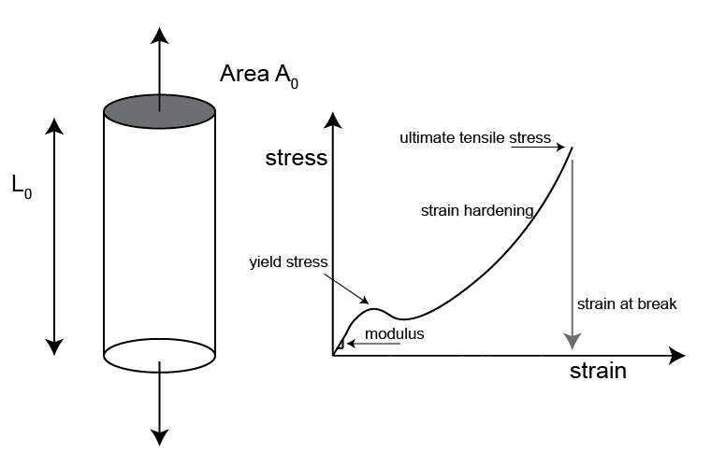

**Stress-Strain Curve for Thick Slime**

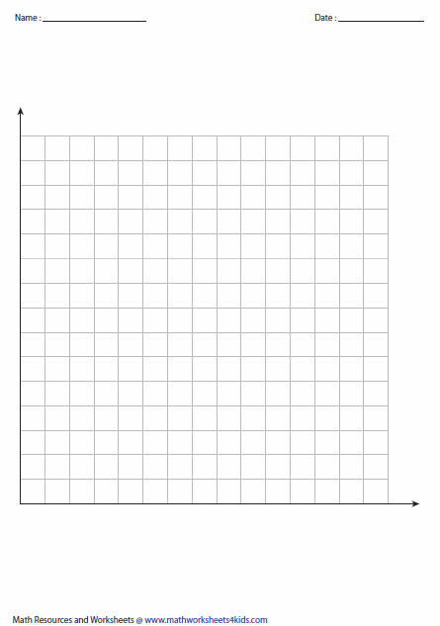

Stress

Strain

**Observations about the graph:** Describe this graph. How is it different from what you expected? How is it similar?

*IF YOU HAVE EXTRA TIME:*

How to make the “fluffy” slime texture:

|  |
| --- |
| **Fluffy** |
| 2/3 cup of glue |
| 2-3 drops of food coloring |
| ⅓ cup of shaving cream |
| 1 level spoonfuls of baking soda |
| 4 level spoonfuls of contact solution |

1. Pour the glue into a cup.
2. Add 2-3 drops of your choice of food coloring and stir until well mixed.
3. Mix in the shaving cream a little bit at a time until it’s all mixed in..
4. Add the baking soda, and mix all together.
5. Add the contact lens solution, and mix all together.
6. Fill out Discussion Question 1 regarding the “Fluffy” slime.

|  |  |  |  |
| --- | --- | --- | --- |
| **Type** | **Texture** | **Appearance** | **Does it bounce? (Y/N)** |
| **Fluffy** |  |  |  |